Chapter 8 Main memory
Topic as per syllabus | As per Text Book
Memory management strategies: Background, Swapping, Contiguous  Memory Allocation, Segmentation, Paging, Structure of Page Table | Chapter 8 Main Memory  8.1 Background 351  8.2 Swapping 358  8.3 Contiguous Memory Allocation 360  8.4 Segmentation 364  8.5 Paging 366  8.6 Structure of the Page Table 378
Virtual Memory Management: Background, Demand paging, copy on write, Page replacement algorithms, Allocation of frames, Thrashing. | Chapter 9 Virtual Memory  9.1 Background 397  9.2 Demand Paging 401  9.3 Copy-on-Write 408  9.4 Page Replacement 409  9.5 Allocation of Frames 421  9.6 Thrashing 425

Introduction:
Memory management is a fundamental aspect of operating systems that involves efficiently allocating, utilizing, and reclaiming memory resources to meet the needs of various processes. The primary goal is to optimize the use of limited memory resources while ensuring system stability and performance.

In modern computing, memory management plays a crucial role in bridging the gap between fast, volatile main memory (RAM) and slower, non-volatile storage. Effective memory management ensures that multiple processes can execute concurrently, providing smooth multitasking and efficient resource utilization.

Section Number | Title | Main Topics Covered
8 | Main Memory | Memory management in operating systems
8.1 | Background | Introduction to memory management concepts
8.1.1 | Basic Hardware | RAM, registers, MMU, logical and physical addresses, protection hardware
8.1.2 | Address Binding | Compile-time, load-time, and execution-time binding
8.1.3 | Logical Versus Physical Address Space | Logical addresses, physical addresses, virtual addresses, MMU translation
8.1.4 | Dynamic Loading | Loading routines only when needed, better memory utilization
8.1.5 | Dynamic Linking and Shared Libraries | Dynamic linking, shared libraries, stubs, runtime linking, memory sharing

  - Background
Memory is essential to modern computer systems, functioning as a large array of addresses accessed by the CPU during instruction execution. The CPU fetches instructions and data from memory based on the program counter, while the memory unit handles only address streams without knowing their purpose. Key topics in memory management include binding symbolic addresses to physical ones, differentiating logical and physical addresses, and dynamically loading code and libraries. Instruction cycles typically involve fetching, decoding, and executing instructions, often requiring memory access for operands and results.
8.1.1 Basic Hardware
The CPU can directly access only registers and main memory, with no machine instructions supporting direct disk access. Data and instructions must be in registers or main memory to be processed. Registers offer faster access, typically within one CPU cycle, while main memory access may require multiple cycles, causing processor stalls. To mitigate this, fast intermediate storage called cache is used. Memory protection ensures correct operation, isolating processes from each other and the operating system.
CPUs experience performance bottlenecks when fetching data from slower main memory over the memory bus, causing processor stalls. The hardware remedy is to integrate fast cache memory into the CPU chip. Additionally, hardware-level protection mechanisms are necessary to secure operating systems and user processes from unauthorized memory access.
In modern operating systems, memory management balances fast and efficient memory usage with protection and safe sharing among multiple processes.
1. The Memory Speed Gap
- CPU Registers: Registers are small memory units inside the CPU that can be accessed very quickly, allowing the processor to execute instructions at very high speed.
- Main Memory (RAM): Located off-chip, main memory is accessed via an external memory bus, which takes multiple clock cycles.
- The Problem: The speed discrepancy forces processors to "stall" (wait) for data.
- The Hardware Remedy: Cache memory is placed between the CPU and main memory. Managed automatically by the hardware, it keeps frequently accessed data readily available, preventing processor stalls without requiring operating system intervention

2. The Need for Hardware-Enforced Protection
In any multiuser or multi programmed operating system, memory cannot be a free-for-all. Correct and secure system operation requires:
- Protecting the OS: Shielding core operating system code and data structures from rogue or malicious user processes.
- Protecting User Processes: Shielding user programs from overwriting or reading the data of other users.
Why Memory Protection Must Be Implemented by Hardware
The operating system cannot check every memory access made by the CPU because the CPU accesses memory millions of times very quickly. If the OS handled every access, the system would become very slow.
So, hardware provides fast memory protection automatically.
Common Hardware Protection Methods
- Base and Limit Registers
These registers check whether a process is accessing memory only within its allowed range.
- Memory Management Unit (MMU)
The MMU converts logical addresses into physical addresses and controls access permissions such as read, write, and execute.
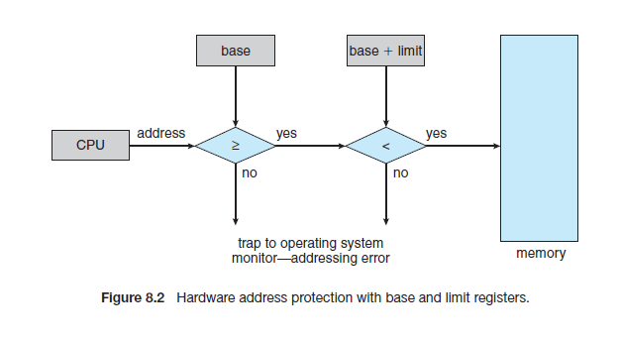

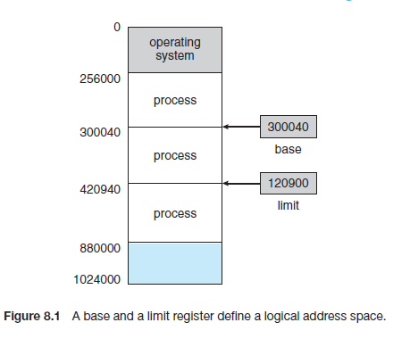

This is achieved using base and limit registers, which define the legal memory range for a process. Any unauthorized memory access triggers a system trap, treating it as an error. Only the operating system, operating in kernel mode, can modify these registers, ensuring secure and controlled memory access

Loader, Logical Address, Physical Address, and MMU
A program that is not running normally exists only as an executable file on the hard disk or SSD. At this stage, the program is simply stored permanently and is not yet part of the active memory of the computer. When the user runs the program, the operating system starts the loader. The loader is responsible for copying the executable program from the hard disk into a free region of RAM. It also prepares the process for execution by setting up memory areas such as code, data, stack, and heap. Thus, the loader plays an important role in moving the program from secondary storage into main memory so that execution can begin.
Even after the program is physically placed inside RAM, modern systems usually do not allow the CPU to directly use physical memory addresses. Instead, the CPU works with logical addresses, also called virtual addresses. A logical address is the address generated by the program and CPU, usually starting from 0 as if the process owns its own private memory space. For example, a variable may appear at logical address 20 from the beginning of the program, regardless of where the program is actually placed in RAM. This gives every process a simple and independent view of memory.
The actual RAM location where the program resides is called the physical address. For example, the loader may place the program physically at RAM location 5000, meaning logical address 20 actually exists at physical address 5020. The conversion from logical address to physical address is performed dynamically by a hardware component called the Memory Management Unit (MMU). The MMU sits between the CPU and RAM and translates every logical address generated by the CPU into the correct physical RAM address before memory is accessed.
The MMU is extremely important in modern operating systems because it supports virtual memory, process isolation, protection, paging, swapping, and multitasking. Since the CPU uses logical addresses, the operating system can move programs to different RAM locations without changing the program code itself. For example, logical address 20 may initially map to physical address 5020 and later to 9020 if the process is moved in memory. The program continues to run correctly because the MMU automatically updates the mapping. Thus, the combination of the loader, logical addressing, physical memory, and MMU forms the foundation of modern memory management systems.

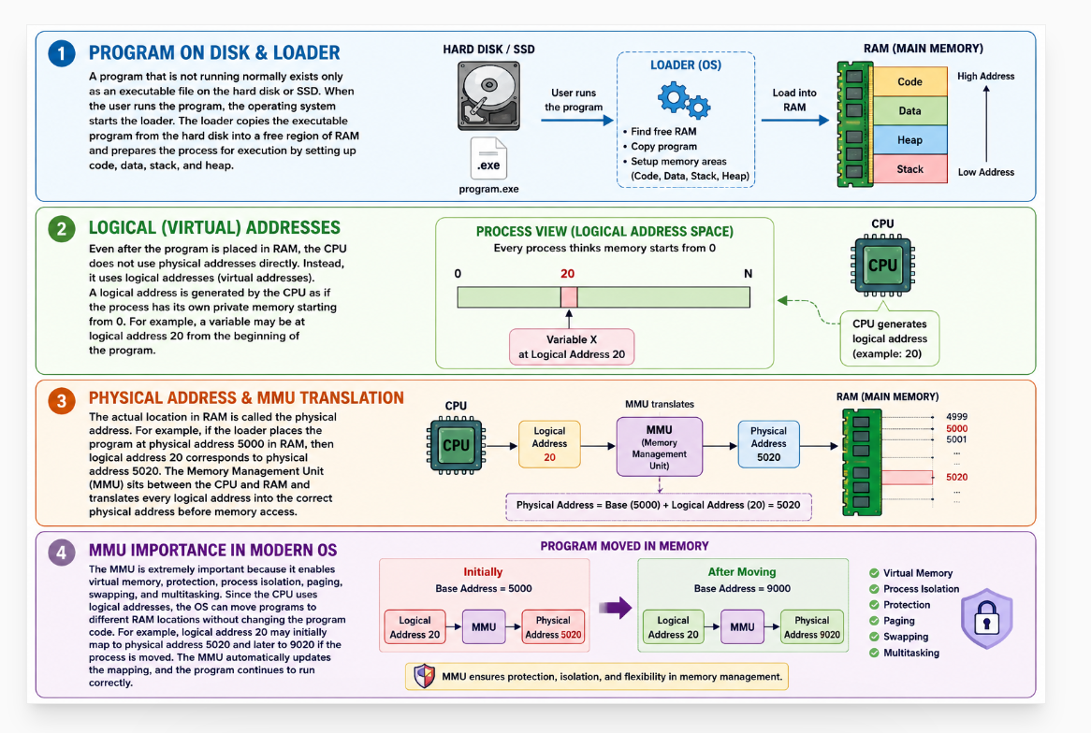

    - Address Binding
Address binding is the process of mapping symbolic program addresses to actual physical memory addresses, enabling seamless program execution. This concept is crucial in operating systems, as it ensures that instructions and data are correctly located and accessed in memory. The binding process can occur at various stages during program execution, offering different levels of flexibility and efficiency.

Types of Addresses in a Program
To understand address binding, it is essential to distinguish between different types of addresses used in a program:
      - Symbolic Addresses:
        - Found in source code, such as variable names and function labels.
        - These addresses are abstract and do not correspond directly to physical memory.
      - Logical (Virtual) Addresses:
        - Generated by the CPU during program execution.
        - These addresses form the logical address space visible to the process.
        - Logical addresses are independent of physical memory and are mapped to actual locations using address binding.
      - Physical Addresses:
        - Actual locations in main memory.
        - These addresses are visible to the memory unit and refer to physical storage in RAM.

Address Binding Process

Compile-time binding fixes addresses inside the executable file stored on disk, load-time binding fixes addresses when the program is loaded into RAM, and execution-time binding dynamically converts logical addresses to physical RAM addresses while the program is running.

The process of binding symbolic or logical addresses to physical addresses can occur at different stages of a program’s lifecycle:

- Compile-Time Binding:
  - Occurs when the program is compiled.
  - If the memory location of the program is known at compile time, the compiler translates symbolic addresses directly into absolute physical addresses.
  - Limitation: The program must always run in the same memory location.
  - Example: Embedded systems or simple batch systems where programs are loaded into predefined memory locations.
- Load-Time Binding:
  - Occurs when the program is loaded into memory.
  - The loader translates symbolic addresses into relocatable addresses, which are adjusted to the actual memory location at load time.
  - Provides flexibility by allowing programs to load into different memory areas.
  - Example: Systems with relocatable code, where programs are not fixed to specific memory addresses.
- Execution-Time Binding:
  - Performed dynamically during program execution.
  - Logical addresses are translated to physical addresses by the Memory Management Unit (MMU).
  - Supports features like dynamic relocation and virtual memory, enabling programs to move between memory locations without altering their execution.
  - Example: Multitasking systems and virtual memory systems where processes share memory.
8.1.3 Logical Versus Physical Address Space

Logical Address Space vs. Physical Address Space
  - Logical Address Space:
    - The set of all logical addresses a process can generate.
    - Represents the program's view of memory, defined by the program's code and data structure.
  - Physical Address Space:
    - The set of all physical addresses available in the system.
    - Represents the actual locations in main memory where data is stored.
In systems with execution-time binding, logical and physical address spaces differ significantly, enabling features like process isolation and memory abstraction.

Importance of Address Binding
- Dynamic Relocation: Allows programs to be moved in memory during execution without affecting their functionality.
- Flexibility: Supports processes in dynamic environments, such as multitasking and virtual memory systems.
- Efficient Resource Utilization: Enables operating systems to allocate and manage memory resources more effectively.
- Abstraction: Separates program memory from physical memory, simplifying program design and development.

Address Binding in Modern Systems
Modern operating systems rely heavily on execution-time binding due to its flexibility and ability to support advanced memory management techniques like paging, segmentation, and virtual memory. These techniques allow processes to use more memory than physically available, share memory efficiently, and provide isolation between processes.
Address binding is a core concept in memory management, ensuring that symbolic and logical addresses are accurately mapped to physical memory during program execution. By facilitating features like dynamic relocation and memory abstraction, address binding contributes to the efficiency, flexibility, and scalability of modern operating systems.

Logical Versus Physical Address Space
In operating systems, the logical address space and physical address space are fundamental concepts in memory management. They help distinguish between how a program perceives memory and how the memory is physically implemented. Understanding the distinction between these address spaces is essential for efficient memory management, program execution, and system design.

Logical Address Space
The logical address space, also known as the virtual address space, refers to the set of addresses that a process can use to reference memory. These addresses are generated by the CPU during program execution. Logical addresses are an abstraction provided by the operating system to simplify memory management and enhance flexibility.

Characteristics of Logical Address Space:
      - Generated by the CPU:
        - These addresses are part of the program's perspective and are used during instruction execution.

      - Defined by the Program:
        - Logical addresses depend on the program's structure, including its variables, code, and data segments.
      - Independent of Physical Memory:
        - Logical addresses do not directly correspond to physical locations in memory.
      - Isolated for Each Process:
        - Each process operates within its own logical address space, providing isolation and security.

Example of Logical Address Space:
A program might access memory locations such as 0x0010, 0x0020, etc., but these are logical addresses that need to be mapped to actual physical memory by the operating system.

Physical Address Space
The physical address space refers to the set of all addresses that are available in the physical memory (RAM) of the computer. Physical addresses represent the actual locations in memory where data is stored.

Characteristics of Physical Address Space:
- Visible to the Memory Unit:
  - Physical addresses directly reference memory cells in the RAM.
- Dependent on Hardware:
  - The size of the physical address space is determined by the amount of physical memory installed in the system.
- Shared Resource:
  - Physical memory is shared among all processes and managed by the operating system.

Example of Physical Address Space:
If a computer has 4 GB of RAM, its physical address space will range from 0x00000000 to 0xFFFFFFFF in a 32-bit addressing system.

Relationship Between Logical and Physical Address Space
The operating system and the Memory Management Unit (MMU) are responsible for translating logical addresses into physical addresses. This translation occurs dynamically and depends on the memory management strategy employed.

Scenarios in Logical and Physical Address Space:
- Identical Address Spaces:
  - In simple systems without virtual memory, logical and physical addresses are identical.
  - Example: Single-tasking systems or those using compile-time address binding.
- Different Address Spaces:
  - In systems using multitasking, virtual memory, or execution-time address binding, logical and physical addresses differ.
  - The MMU translates logical addresses to physical addresses at runtime.

Benefits of Separating Logical and Physical Address Space
- Process Isolation:
  - Logical addresses ensure that each process operates in its own memory space, preventing interference from other processes.
- Memory Abstraction:
  - Logical addresses abstract the complexity of physical memory, allowing programs to be written without knowledge of hardware details.
- Dynamic Memory Management:
  - Enables features like virtual memory, paging, and segmentation, which enhance memory utilization and flexibility.
- Scalability:
  - Processes can use more memory than physically available, as logical addresses can extend beyond physical memory limits (e.g., with virtual memory).

Practical Example of Logical vs. Physical Address Translation Scenario:
A program accesses a variable at a logical address 0x1234.
- The MMU translates 0x1234 to the physical address 0xA234 in RAM.
- The operating system determines this mapping using page tables or segment tables, depending on the memory management strategy.

The distinction between logical and physical address spaces is crucial in modern operating systems. Logical addresses provide an abstraction that simplifies program development and enables advanced features like virtual memory and process isolation. The translation of logical addresses to physical addresses ensures efficient and secure utilization of memory resources, making it a cornerstone of memory management strategies.

    - Dynamic Loading
Dynamic loading is a memory management technique where a program loads its routines or modules into memory only when they are needed during execution. This approach optimizes memory usage by avoiding the unnecessary loading of unused program components, thereby improving the efficiency of system resource utilization.
In traditional loading methods, all parts of a program are loaded into memory before execution begins. In contrast, dynamic loading defers the loading of certain parts, such as functions or libraries, until they are explicitly called. This technique is particularly useful for large programs where not all functions are required in every execution instance.

Example of Dynamic Loading Scenario:
A text editor program consists of a main editing module and additional features like a grammar checker.
- At Startup: Only the main module is loaded.
- When Grammar Check is Invoked: The operating system loads the grammar checker module dynamically.
- After Use: The module may stay in memory or be unloaded, depending on the memory management policy.
Dynamic loading is a powerful memory management strategy that enhances the efficiency and flexibility of program execution. By loading only the required parts of a program on demand, it minimizes memory usage and supports the development of modular and extensible software. While it introduces some runtime overhead, its benefits in optimizing memory and enabling large-scale applications make it a critical feature in modern operating systems.
    - Dynamic Linking and Shared Libraries
Dynamic linking is the process of linking program modules (such as functions or libraries) to a program at runtime, rather than during the compilation process. When a program is compiled, it contains references to external libraries, but the actual linking of these references to the library code occurs only when the program is executed.

Dynamic linking is a memory-management technique in which library linking is postponed until the program is actually executed. In static linking, all required library routines are copied into the executable file before execution. This increases the size of the executable and wastes both disk space and RAM because every program stores its own copy of the library code. Dynamic linking solves this problem by allowing programs to share a single copy of common libraries during execution.

In dynamic linking, the executable program does not contain the actual library routine code. Instead, it contains a small piece of code called a stub. The stub acts like a placeholder or helper routine. When the program tries to use a library function, the stub checks whether the required library routine is already present in memory. If the routine is already loaded, the stub directly connects the program to that routine. If the routine is not present, the operating system loads the required library into memory from disk.

After the library routine is loaded, the stub replaces itself with the actual address of the routine. Then the routine is executed normally. The next time the program calls the same function, the address is already known, so the routine is executed directly without repeating the loading process. Thus, dynamic linking introduces overhead only during the first call.

A major advantage of dynamic linking is memory saving. Many programs running in the system can share a single copy of a library. For example, several programs using the C standard library can all use the same library code already loaded in memory. This reduces duplication of code in RAM and improves memory utilization.

Dynamic linking also simplifies library updates. Suppose a bug is fixed in a library. If dynamic linking is used, replacing the old library with the new version automatically allows all programs to use the updated library without recompilation or relinking. In static linking, every program would need to be recompiled and relinked separately.

To avoid incompatibility problems, version information is maintained for both programs and libraries. Different versions of the same library may coexist in memory. Programs use version numbers to determine which library version they should use. Minor updates usually keep the same version number, while major incompatible changes receive a new version number. This ensures older programs continue working correctly even after new library versions are installed.

  - Swapping:
Section | Subtopics
8.2 Swapping | Moving processes between RAM and disk
8.2.1 Standard Swapping | Swap in, swap out, backing store, process relocation, context switching
8.2.2 Swapping on Mobile Systems | Flash memory limitations, mobile OS restrictions, memory compression, avoiding excessive swapping

8.2.1 Standard Swapping

Standard swapping is a memory-management technique where processes are temporarily moved between RAM and disk (backing store). This helps the system run more processes than the actual RAM size, increasing multiprogramming.
The operating system keeps a ready queue of processes. When the CPU scheduler selects a process, the dispatcher checks whether it is present in RAM. If memory is full, another process is swapped out to disk, and the required process is swapped into RAM. After restoring CPU registers, execution continues.
Swapping is slow because transferring processes between RAM and disk takes significant time. Therefore, modern operating systems use modified swapping techniques together with virtual memory.
Swapping introduces high context-switch time because processes must be transferred between RAM and disk. For example, swapping a 100 MB process using a disk transfer speed of 50 MB/s takes about 2 seconds for swap out and another 2 seconds for swap in, resulting in nearly 4 seconds total swap time. The major part of swapping overhead comes from data transfer time, which increases with process size. Smaller processes swap faster than larger processes. Therefore, it is better to swap only the memory actually being used by the process instead of the entire allocated memory. Processes with changing memory needs inform the operating system using system calls like:
request_memory()
release_memory()
to help reduce swapping overhead.
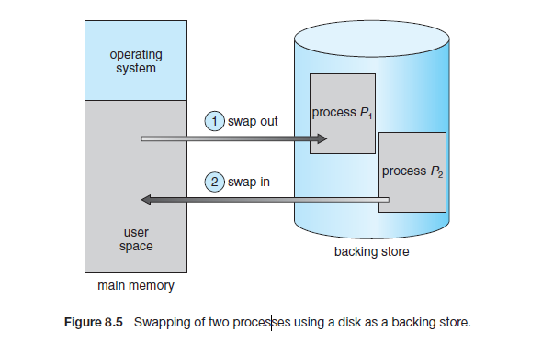
Swapping cannot be performed if a process has pending I/O operations because the device may try to access memory that has already been reassigned to another process after swapping. To avoid this problem, operating systems either avoid swapping processes with pending I/O or use operating-system buffers for data transfer. Standard swapping is rarely used in modern operating systems because it causes high overhead and slow performance. Modern systems instead use modified swapping techniques, such as swapping only when free memory becomes low or swapping only portions of processes together with virtual memory.

Example of Swapping
Consider a computer with 4GB of RAM and 6GB of active processes running at the same time. The operating system can use swapping to manage memory by performing the following steps:
- Initial Condition:
  - The system is running multiple processes, each requiring memory, but there is only 4GB of RAM available. Some processes must be swapped out to free up space for new processes.
- Process Swapping:
  - The operating system identifies a process that is not currently in use and swaps it out to secondary storage (e.g., hard disk).
- Memory Allocation:
  - The system then loads a new process into the freed-up memory space.
- Swapping Back:
  - When the swapped-out process is needed again, the operating system swaps it back into memory and removes another process that is not in use.

8.2.2 Swapping on Mobile Systems
Most mobile operating systems do not support traditional swapping because mobile devices use flash memory instead of large hard disks. Flash memory has limited storage space, slower transfer speed, and a limited number of write operations, making frequent swapping inefficient and harmful to device life.
Instead of swapping, mobile operating systems use alternative memory-management techniques. In Apple iOS, when free memory becomes low, applications are asked to voluntarily release unused memory. Read-only data such as program code may be removed and later reloaded from flash memory if needed, while modified data such as stack contents are retained. Applications that fail to release enough memory may be terminated by the operating system.
Android also avoids traditional swapping. When free memory becomes insufficient, Android may terminate background processes to free memory. Before termination, Android saves the application state to flash memory so the application can restart quickly later.
Because of these limitations, mobile application developers must carefully manage memory and avoid memory leaks. Although mobile systems do not generally support swapping, both Android and iOS support paging for efficient memory management.

  - Contiguous Memory Allocation:
Contiguous memory allocation is a method where the main memory is divided into two partitions: one for the operating system and one for user processes. Typically, the operating system is placed in low memory, often due to the location of the interrupt vector. In this approach, several user processes are allocated memory in contiguous blocks. Each process is loaded into a single contiguous section of memory, which simplifies memory management but can lead to issues like fragmentation. The challenge lies in efficiently allocating memory to processes waiting to be loaded while minimizing wasted space.

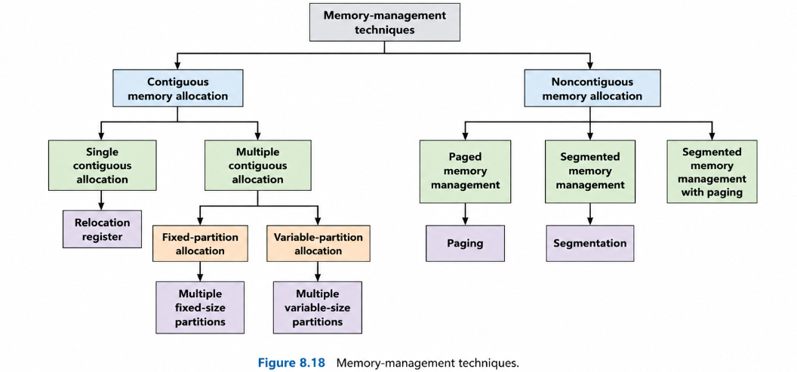
Section | Subtopics
8.3 Contiguous Memory Allocation | Single contiguous allocation, multiple contiguous allocation
8.3.1 Memory Protection | Relocation register, limit register, MMU-based protection
8.3.2 Memory Allocation | Fixed-partition allocation, variable-partition allocation, holes, input queue, First Fit, Best Fit, Worst Fit
8.3.3 Fragmentation | Internal fragmentation, external fragmentation, compaction
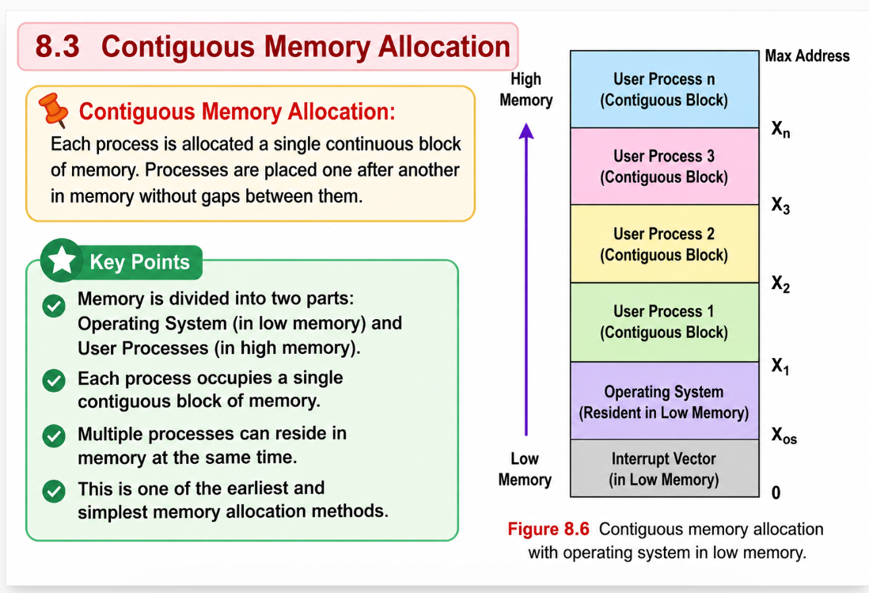
8.3.1 Memory Protection
Memory protection prevents a process from accessing memory that does not belong to it by using the relocation register and limit register together with the MMU. The relocation register stores the starting physical address of the process, while the limit register stores the valid range of logical addresses. Every logical address generated by the CPU is checked against the limit register, and the MMU converts valid logical addresses into physical addresses by adding the relocation value. During a context switch, the dispatcher loads the correct relocation and limit values for the selected process. This mechanism also allows the operating system size to change dynamically using transient operating-system code that is loaded only when needed.
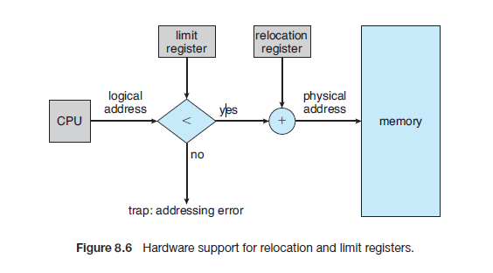
Memory protection uses relocation and limit registers with the MMU to ensure that a process accesses only its own memory region and cannot modify operating-system or other process memory.

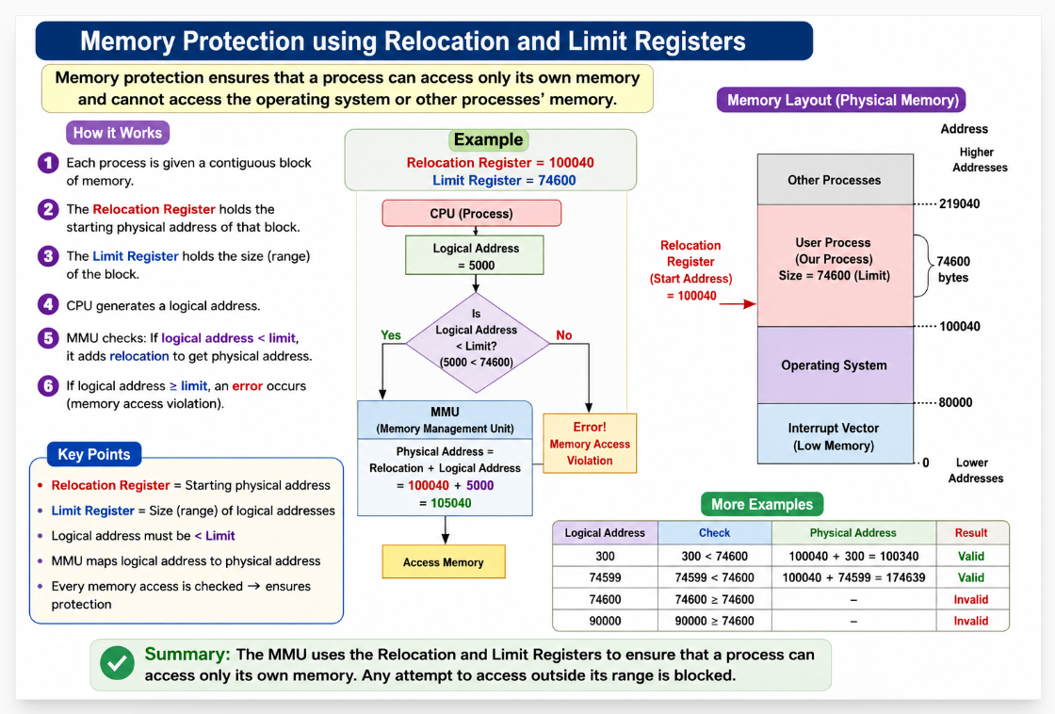

8.3.2 Memory Allocation
Memory allocation assigns RAM space to processes for execution. In the fixed-partition scheme, memory is divided into fixed-size partitions, and each partition holds one process. The number of processes that can run simultaneously depends on the number of partitions. In the variable-partition scheme, memory is allocated according to process size, and free memory blocks are called holes. Processes from the input queue are loaded into suitable holes, and if a hole is larger than needed, it is split into two parts. When a process terminates, its memory is released and adjacent free holes are merged to form larger holes for future allocation

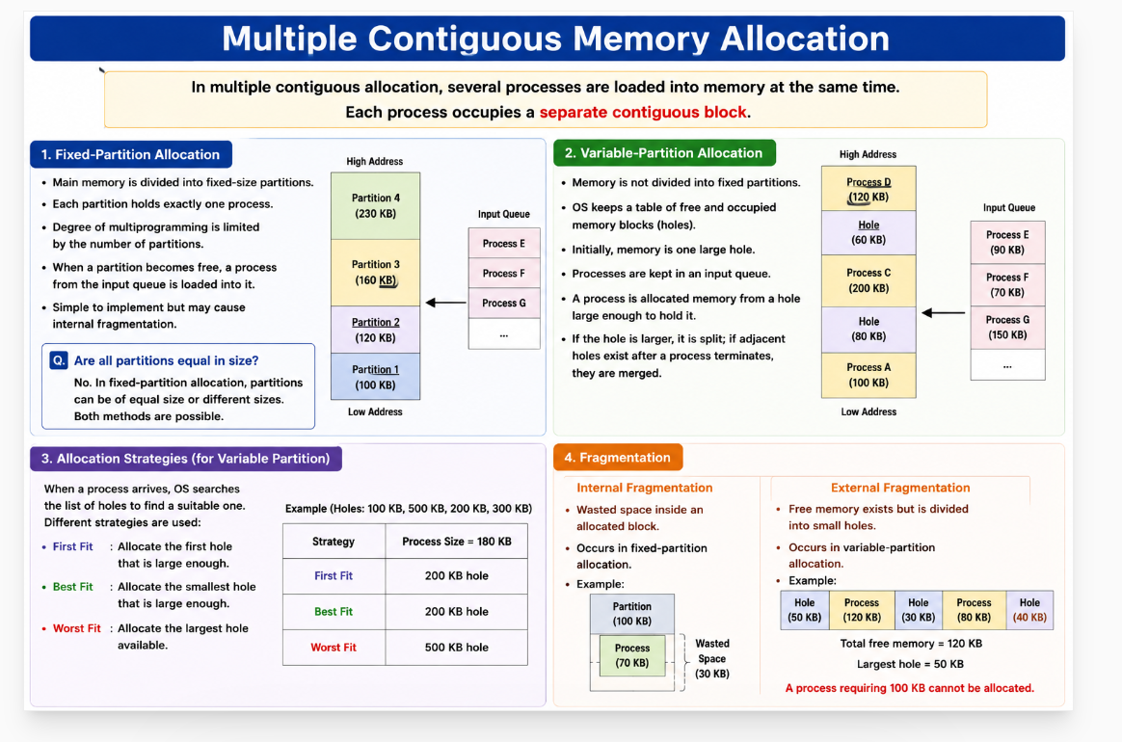

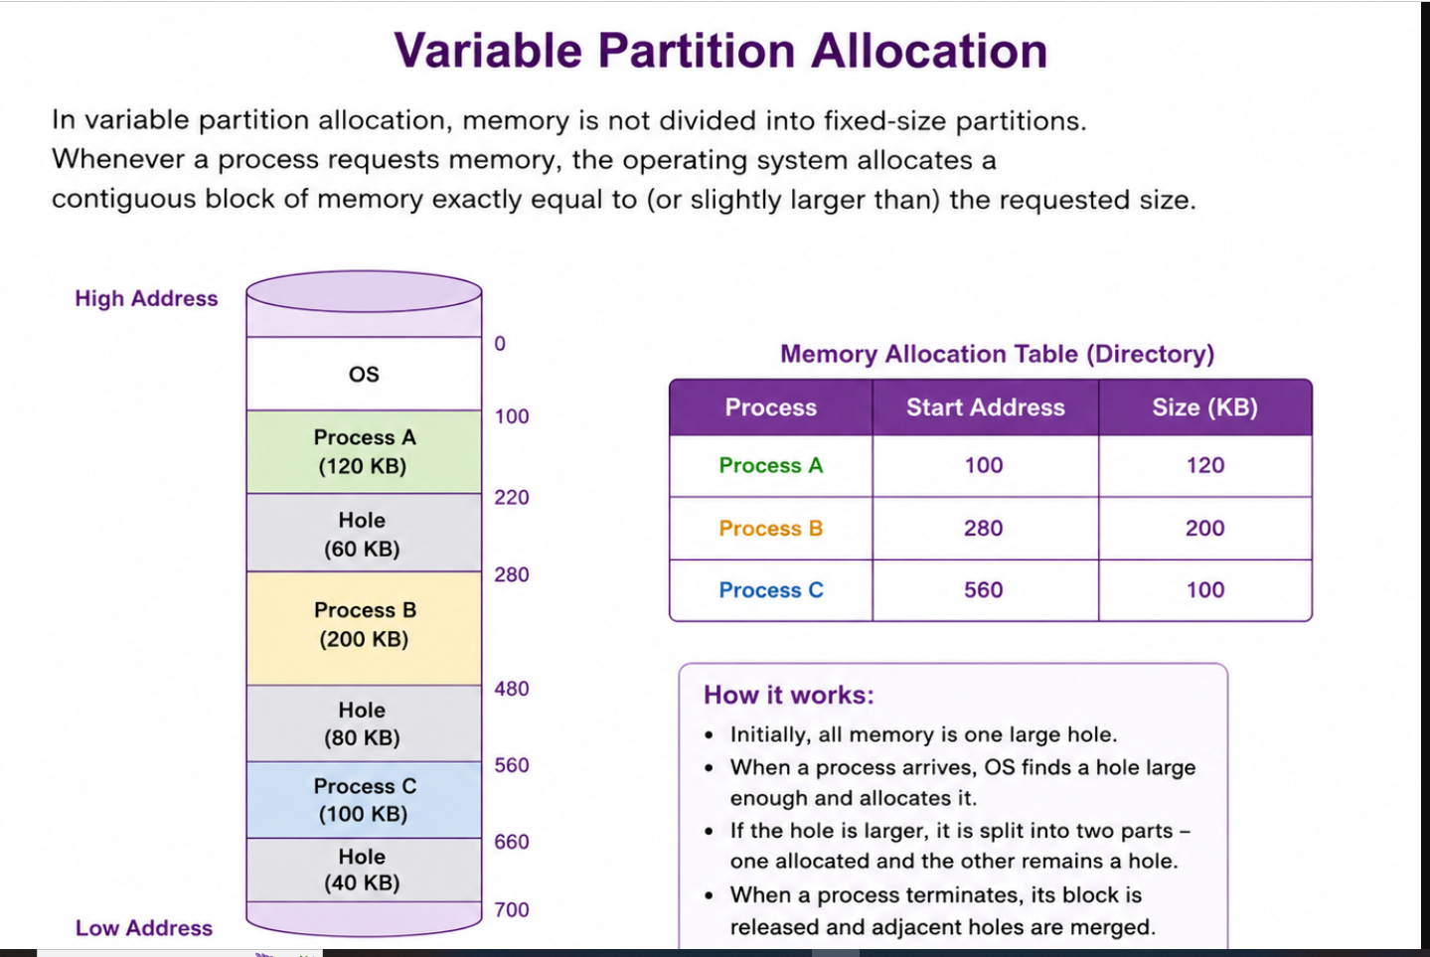
The dynamic storage-allocation problem deals with allocating a memory request of size n from the available free memory holes. The operating system uses different allocation strategies to choose a suitable hole.
- First-Fit: Allocates the first hole that is large enough for the process. It is fast because searching stops as soon as a suitable hole is found.
- Best-Fit: Allocates the smallest hole that is large enough. It searches the entire list and produces the smallest leftover hole, improving memory utilization.
- Worst-Fit: Allocates the largest hole available. It leaves the largest remaining hole, which may be useful for future large processes.
These strategies are commonly used in contiguous memory allocation and mainly differ in how they select free memory holes.
Given six memory partitions of 300 KB, 600 KB, 350 KB, 200 KB, 750 KB, and 125 KB (in order), how would the first-fit, best-fit, and worst-fit algorithms place processes of size 115 KB, 500 KB, 358 KB, 200 KB, and 375 KB (in order)? Rank the algorithms in terms of how efficiently they use memory.
First-Fit Allocation
Step | Process | Hole Selected | Allocation | Remaining Hole
1 | A (115 KB) | 300 KB | A → 300 | 185 KB
2 | B (500 KB) | 600 KB | B → 600 | 100 KB
3 | C (358 KB) | 750 KB | C → 750 | 392 KB
4 | D (200 KB) | 350 KB | D → 350 | 150 KB
5 | E (375 KB) | 392 KB | E → 392 | 17 KB

Best-Fit Allocation
Step | Process | Hole Selected | Allocation | Remaining Hole
1 | A (115 KB) | 125 KB | A → 125 | 10 KB
2 | B (500 KB) | 600 KB | B → 600 | 100 KB
3 | C (358 KB) | 750 KB | C → 750 | 392 KB
4 | D (200 KB) | 200 KB | D → 200 | 0 KB
5 | E (375 KB) | 392 KB | E → 392 | 17 KB
Worst-Fit Allocation
Step | Process | Hole Selected | Allocation | Remaining Hole
1 | A (115 KB) | 750 KB | A → 750 | 635 KB
2 | B (500 KB) | 635 KB | B → 635 | 135 KB
3 | C (358 KB) | 600 KB | C → 600 | 242 KB
4 | D (200 KB) | 350 KB | D → 350 | 150 KB
5 | E (375 KB) | No suitable hole | Not Allocated | —
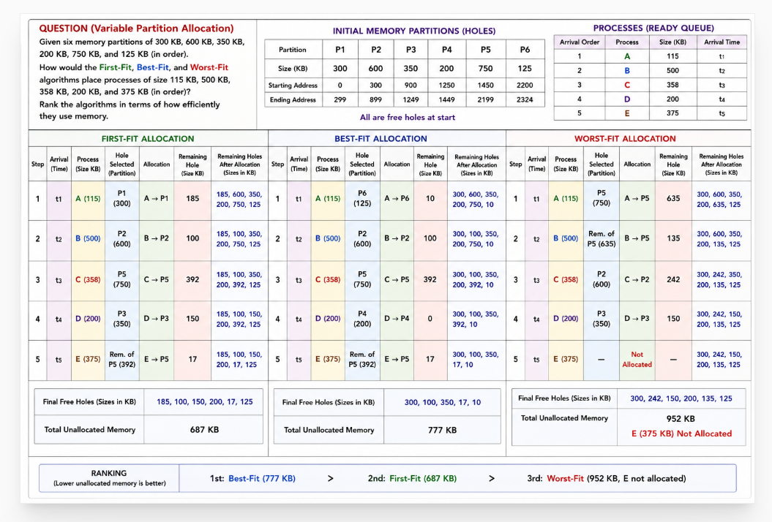

8.3.3 Fragmentation
External fragmentation occurs when free memory is available in many small scattered holes, but no single contiguous hole is large enough to satisfy a process request. It mainly occurs in first-fit and best-fit contiguous memory allocation schemes as processes are repeatedly loaded and removed from memory. Even though the total free memory may be sufficient, the process cannot be allocated because the free spaces are not continuous. In severe cases, small holes may exist between every two processes, wasting a large amount of memory.
The amount of fragmentation depends on the allocation strategy used. Both first-fit and best-fit can lead to external fragmentation, although their efficiency varies depending on the system. A statistical observation called the 50-percent rule states that for every N allocated blocks, approximately 0.5N blocks may be lost due to fragmentation, meaning nearly one-third of memory can become unusable.
Internal fragmentation occurs when allocated memory is slightly larger than the requested memory. The unused space inside the allocated partition becomes wasted memory. This usually happens when memory is allocated in fixed-size blocks. For example, if a process requests 18,462 bytes and a block of 18,464 bytes is allocated, the remaining 2 bytes inside the partition are wasted.
Internal fragmentation happens when the memory assigned to a process is slightly larger than needed, wasting space inside the block. External fragmentation happens when total free memory is sufficient for a request, but it is scattered into small, non-contiguous holes
One solution to external fragmentation is compaction, where the operating system moves processes in memory so that all free holes combine into one large free block. Compaction is possible only when dynamic relocation is supported at execution time. However, compaction is expensive because processes must be moved during execution.
Another solution is to allow noncontiguous memory allocation, where a process can be stored in different memory locations instead of one continuous block. This is achieved using segmentation and paging, which reduce or eliminate external fragmentation and form the basis of modern memory management systems.
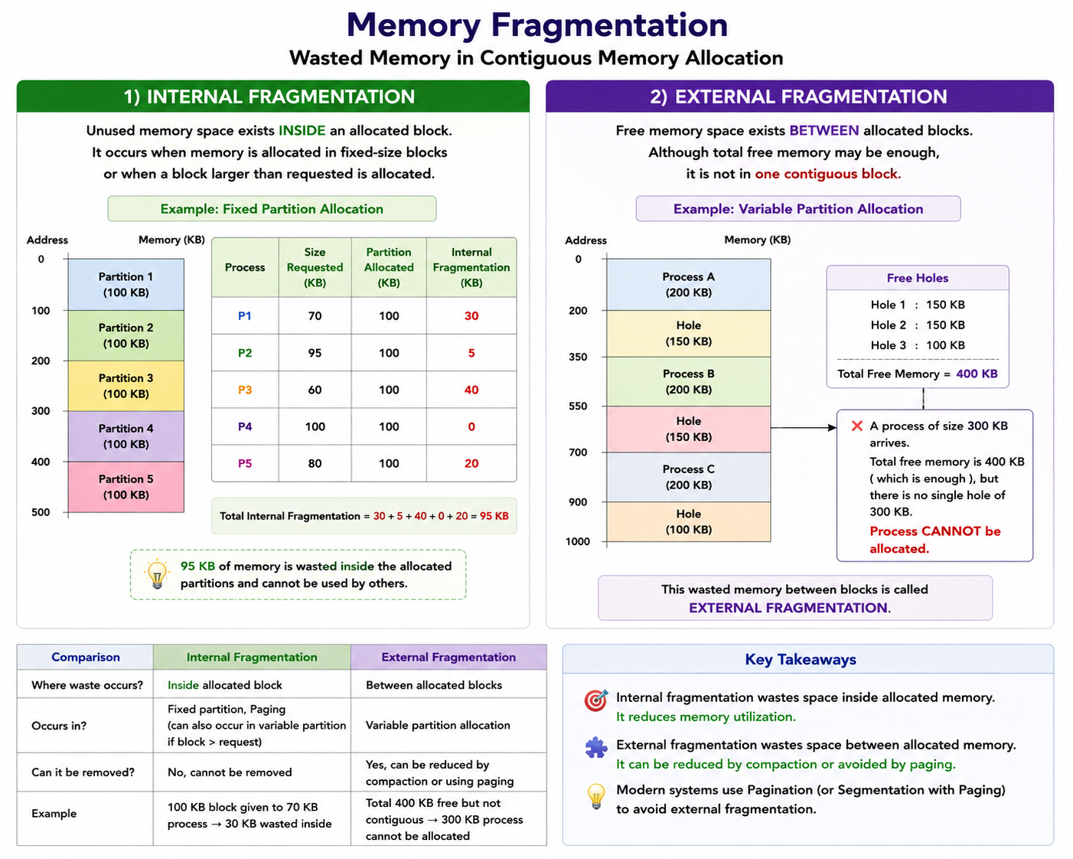
  - Segmentation
Section | Subtopics
8.4 Segmentation | Dividing logical memory into variable-sized segments
8.4.1 Basic Method | User view of memory, segments, segment number, offset, logical address structure
8.4.2 Segmentation Hardware | Segment table, segment-table base register (STBR), segment-table length register (STLR), limit checking, address translation using MMU
The programmer’s view of memory is different from the actual physical memory inside the computer. Working directly with physical memory is difficult for both programmers and the operating system. Segmentation provides a mechanism that maps the programmer’s logical view of memory to physical memory. It allows programs to be divided into meaningful parts called segments (such as code, data, and stack), giving programmers a more natural and flexible way to organize memory while allowing the operating system to manage memory efficiently.

8.4.1 Basic Method
Programmers do not usually think of memory as one long linear array of bytes. Instead, as shown in Figure 8.7, they view a program as a collection of logical segments such as the main program, subroutines, stack, symbol table, and functions like Sqrt(). These segments are variable-sized and may appear in any order in memory.
In segmentation, each program component is treated as a separate segment with its own name and length. A memory address in segmentation consists of two parts:
<segment-number, offset>
where the segment number identifies the segment and the offset specifies the location inside that segment.
The programmer is concerned only with the logical organization of the program and not with the actual physical memory addresses. During compilation, the compiler automatically creates segments such as:
- Code segment
- Global variables
- Heap
- Stack
- Library segments
The loader then assigns segment numbers to these segments for memory management.
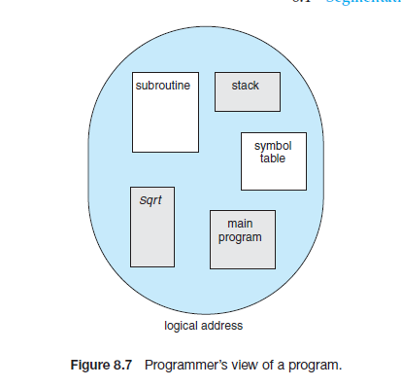
8.4.2 Segmentation Hardware
In segmentation hardware, memory is managed using a segment table. Each entry in the segment table contains two important values:
- Base → starting physical address of the segment
- Limit → length (size) of the segment
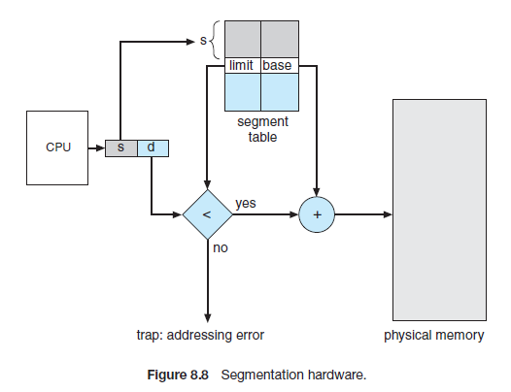
As shown in Figure 8.8, a logical address consists of:
<segment number, offset>
where:
- s = segment number
- d = offset inside the segment
The segment number is used to access the corresponding entry in the segment table. The hardware checks whether the offset value is less than the segment limit. If the offset exceeds the limit, the system generates a trap (addressing error) to the operating system.
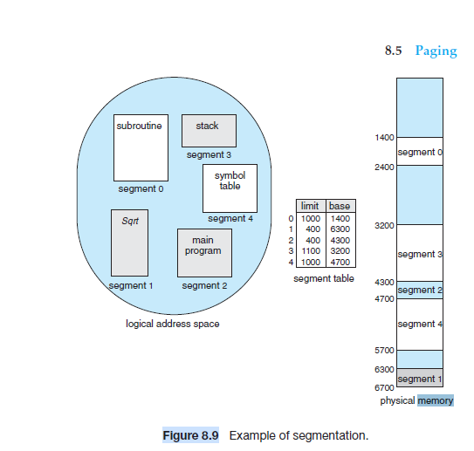
If the offset is valid, the MMU adds:
Physical Address = Base + Offset
to obtain the actual physical memory address.
Example:
Segment | Base | Limit
2 | 4300 | 400
Reference:
<2, 53>
Physical address:
4300 + 53 = 4353
Similarly:
<3, 852>
becomes:
3200 + 852 = 4052
If a process tries to access beyond the segment limit, such as:
<0, 1222>
when segment 0 size is only 1000 bytes, the system generates an addressing error trap.
Thus, segmentation hardware provides:
- logical organization of memory
- memory protection
- dynamic address translation
- easy program modularity

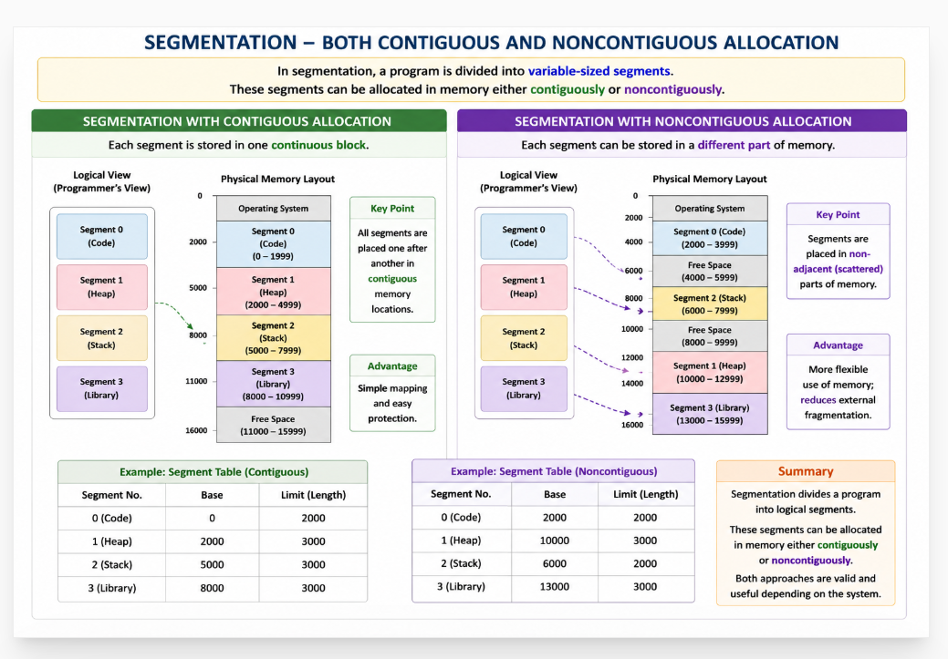

8.5 Paging
Section | Subtopics
8.5 Paging | Noncontiguous memory allocation using pages and frames
8.5.1 Basic Method | Pages, frames, page table, logical address, physical address, page mapping
8.5.2 Hardware Support | Page-table base register (PTBR), translation look-aside buffer (TLB), paging hardware
8.5.3 Protection | Valid-invalid bit, memory protection, access rights
8.5.4 Shared Pages | Shared code, reentrant code, shared memory among processes

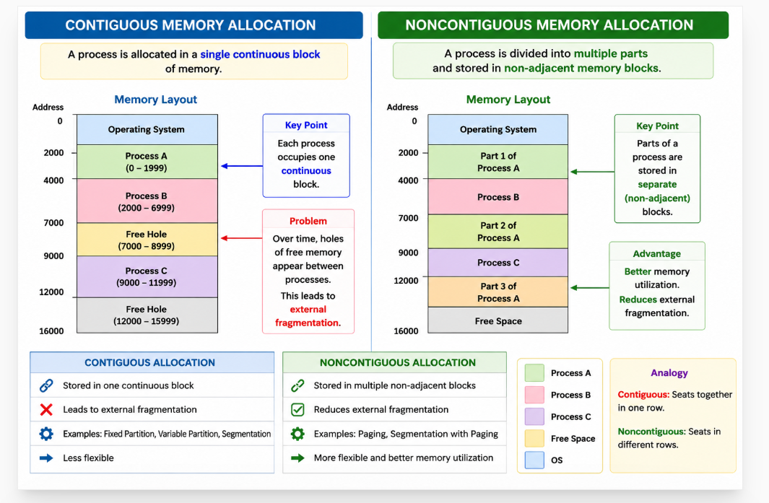

Paging is another noncontiguous memory-management scheme that divides memory into fixed-size pages and frames. Unlike segmentation, paging:
- Eliminates external fragmentation
- Removes the need for compaction
- Makes memory allocation simpler using fixed-size blocks
- Simplifies swapping between RAM and backing store
Earlier memory-management techniques had difficulty fitting variable-sized memory chunks onto the backing store (disk). Since disk access is slow, performing compaction on disk is impractical. Paging solves this problem because all pages are of equal size, making storage and swapping easier and more efficient.
Because of these advantages, paging is widely used in modern operating systems, including systems for:
- mainframes
- desktops
- servers
- smartphones
8.5.1 Basic Method
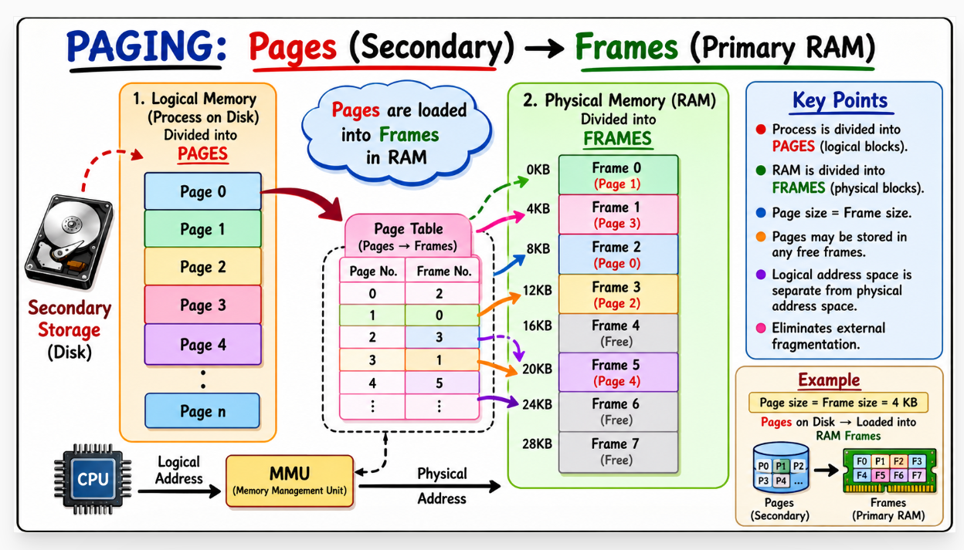
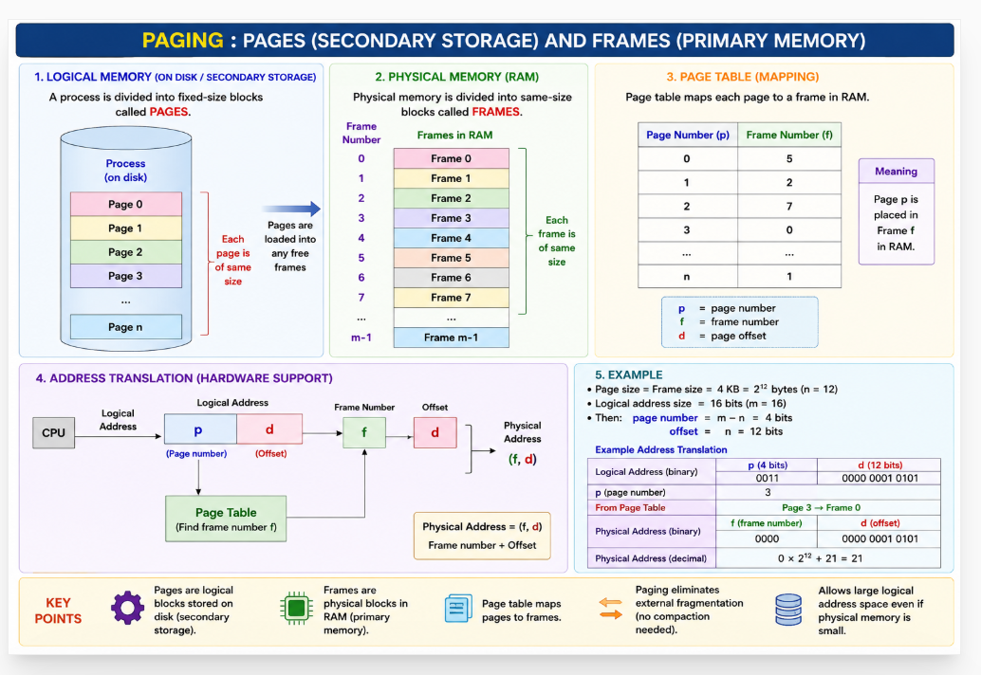

Paging is a noncontiguous memory-management technique in which:
- Physical memory is divided into fixed-size blocks called frames
- Logical memory is divided into equal-sized blocks called pages
Both pages and frames are of the same size. When a process executes, its pages can be loaded into any free frames in RAM. Thus, a process does not need one continuous memory block.
The backing store (disk) is also divided into fixed-size blocks so that pages can be easily moved between disk and RAM. Paging separates the logical address space from the physical address space, allowing a process to have a very large logical memory space even if the actual RAM is smaller.
In paging hardware, every logical address generated by the CPU is divided into two parts:
<p, d>
where:
- p = page number
- d = page offset
The page number is used as an index into the page table. The page table stores the frame number (base address) where each page is located in physical memory. The MMU combines the frame number with the offset to generate the final physical address.
The page size is decided by hardware and is always a power of 2 (such as 512 bytes, 4 KB, etc.). If logical address space size is:
2^m
and page size is:
2^n
then:
- high-order m − n bits represent the page number
- low-order n bits represent the offset
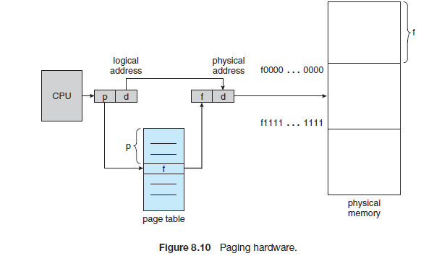
In paging, the page table stores the base address (frame number) of each page in physical memory. When the CPU generates a logical address, the page number is used to find the corresponding frame from the page table. The frame number (base address) is then combined with the page offset to form the final physical address. This physical address is sent to RAM to access the required data or instruction.
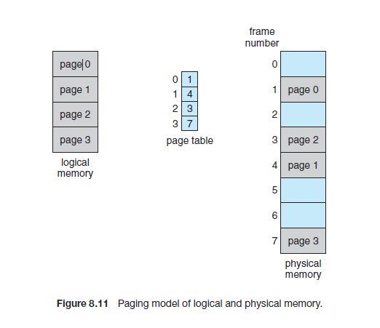

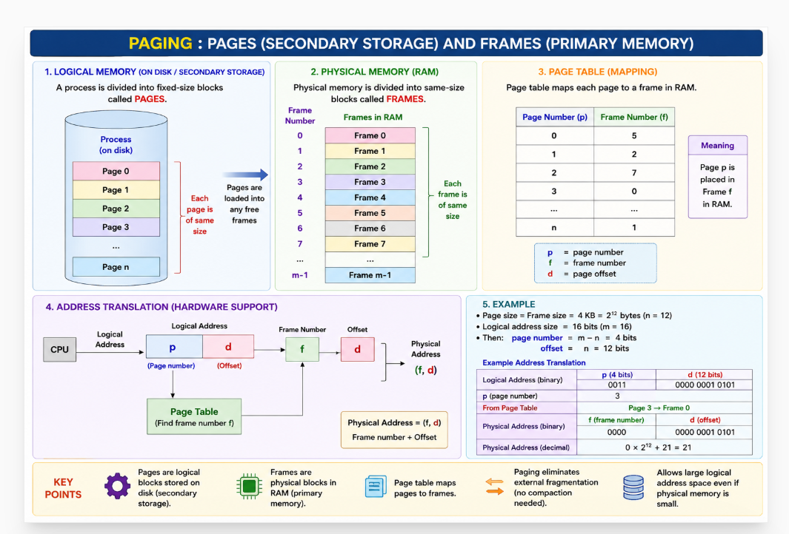

Consider a logical address space of 64 pages of 1,024 words each, mapped onto a physical memory of 32 frames. a. How many bits are there in the logical address? b. How many bits are there in the physical address.
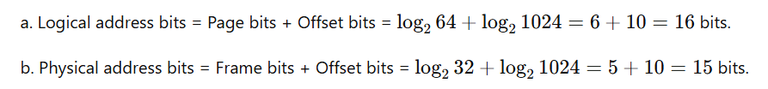
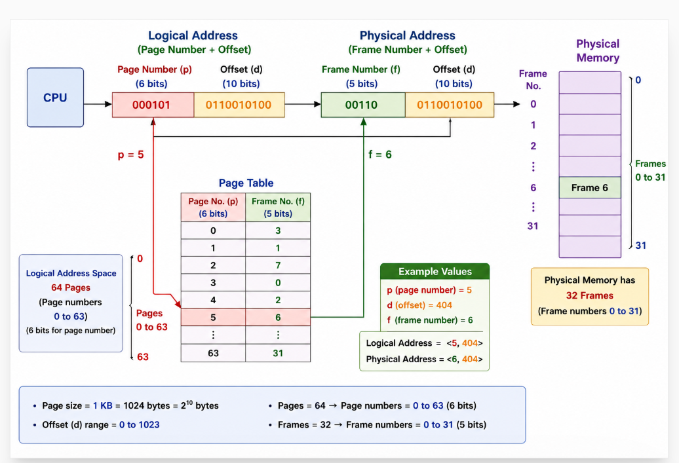

Problem No | Logical Address Space | Page Size | Physical Memory | Find
1 | 64 pages | 1 KB | 32 frames | Logical & Physical address bits
2 | 128 pages | 2 KB | 64 frames | Logical & Physical address bits
3 | 256 pages | 4 KB | 128 frames | Logical & Physical address bits
4 | 32 pages | 1 KB | 16 frames | Logical & Physical address bits
5 | 1024 pages | 8 KB | 512 frames | Logical & Physical address bits

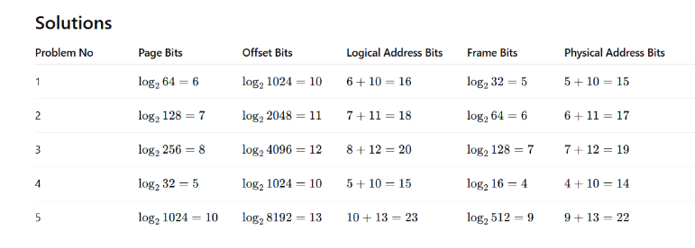
Consider a system with:
- Logical Address (LA) = 7 bits
- Physical Address (PA) = 6 bits
- Page Size = 8 words
Calculate:
- Number of pages
- Number of frames
- Number of offset bits

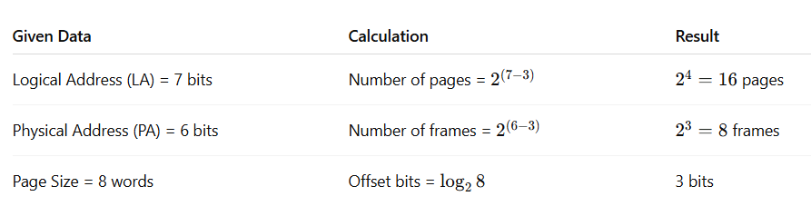
Assuming a 1-KB page size, what are the page numbers and offsets for the following address references (provided as decimal numbers): a. 3085 b. 42095 c. 215201 d. 650000 e. 2000001
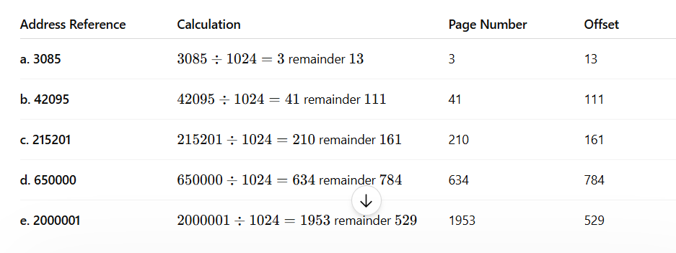

8.5.2 Hardware Support
Paging requires hardware support because every logical address generated by the CPU must be translated into a physical address using the page table. Different operating systems store page tables in different ways. Some systems maintain a separate page table for each process, and the pointer to this page table is stored in the Process Control Block (PCB). During a context switch, the dispatcher reloads the required page-table information for the new process.
Initially, page tables were implemented using high-speed registers for faster address translation. This method works only when the page table is very small. Modern systems, however, may contain millions of page-table entries, making register-based page tables impractical. Therefore, modern operating systems store the page table in main memory and use a special register called the:

Page-Table Base Register (PTBR)
The PTBR stores the starting address of the page table in memory.

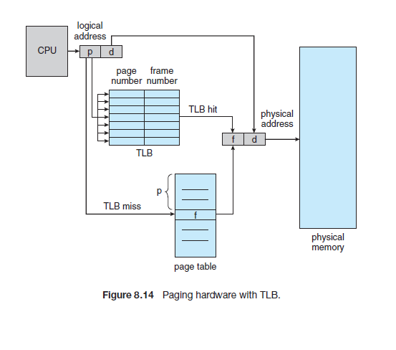

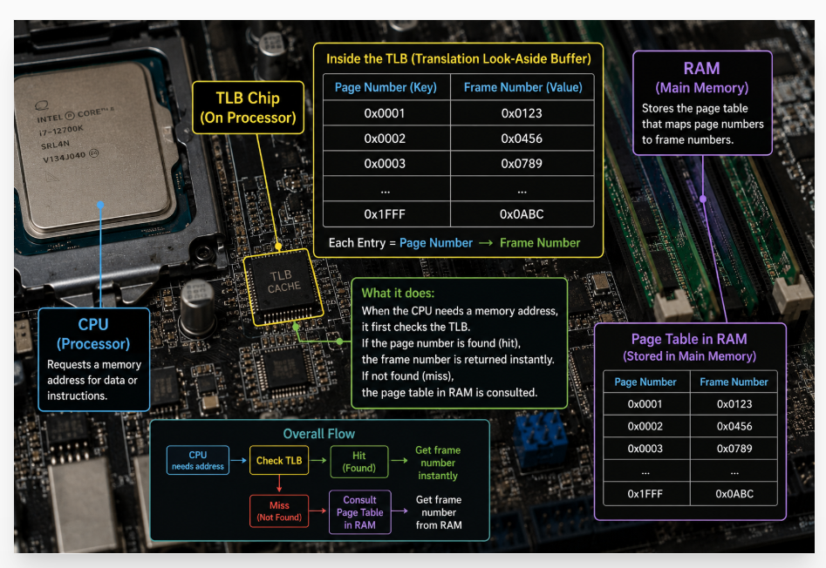

The Translation Look-Aside Buffer (TLB) is a small, fast associative cache memory used to speed up page-table lookups in paging systems. Each TLB entry contains a key (page number) and a value (frame number). When the CPU generates a logical address, the page number is searched in the TLB, and all entries are compared simultaneously using associative memory. If the page number is found (TLB Hit), the corresponding frame number is obtained immediately, allowing direct memory access with almost no delay.
Because TLB lookup is performed as part of the CPU instruction pipeline, it adds virtually no performance overhead. To maintain this speed, the TLB is kept small (typically 32–1024 entries). Some processors provide separate Instruction TLB (ITLB) and Data TLB (DTLB) to improve performance further.
If the page number is not found (TLB Miss), the system accesses the page table in main memory to obtain the frame number. The page-table entry is then added to the TLB for future use. Thus, the TLB significantly reduces address-translation time and improves overall paging performance.

The Hit Ratio is the percentage of times the required page number is found in the TLB. A higher hit ratio means fewer page-table accesses and faster memory access. If the page number is found in the TLB (TLB Hit), only one memory access is required. If it is not found (TLB Miss), the system must first access the page table and then access the required memory location, resulting in two memory accesses.
The Effective Access Time (EAT) is calculated as:
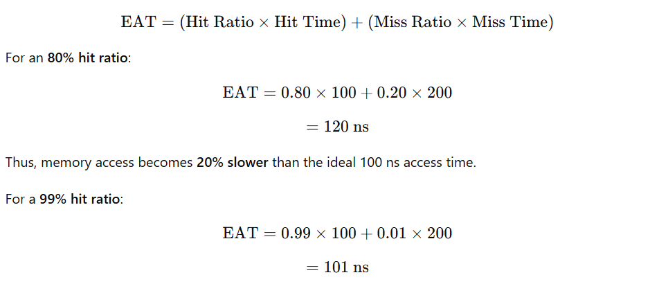
Thus, memory access is only 1% slower, showing that a high TLB hit ratio greatly improves performance.
Modern processors often use multiple levels of TLBs (L1 TLB, L2 TLB). If an entry is not found in the L1 TLB, the CPU searches the L2 TLB. If it is still not found, the system must access the page table in main memory, which can take hundreds of CPU cycles. Therefore, maintaining a high TLB hit ratio is critical for efficient paging performance.
8.5.3 Protection
In a paging system, memory protection is achieved using protection bits stored in each page-table entry. These bits control the type of access allowed for a page, such as read-only, read–write, or execute-only. Whenever a memory reference is made, the hardware checks these protection bits while translating the logical address into a physical address. If a process attempts an illegal operation (for example, writing to a read-only page), a hardware trap occurs and control is transferred to the operating system.
Another important protection mechanism is the Valid–Invalid Bit associated with each page-table entry. A valid (v) bit indicates that the page belongs to the process's logical address space and can be accessed. An invalid (i) bit indicates that the page does not belong to the process, and any access attempt results in an invalid page reference trap.
Page Number | Valid–Invalid Bit | Status
Page 0 | v | Valid
Page 1 | v | Valid
Page 2 | v | Valid
Page 3 | v | Valid
Page 4 | v | Valid
Page 5 | v | Valid
Page 6 | i | Invalid
Page 7 | i | Invalid

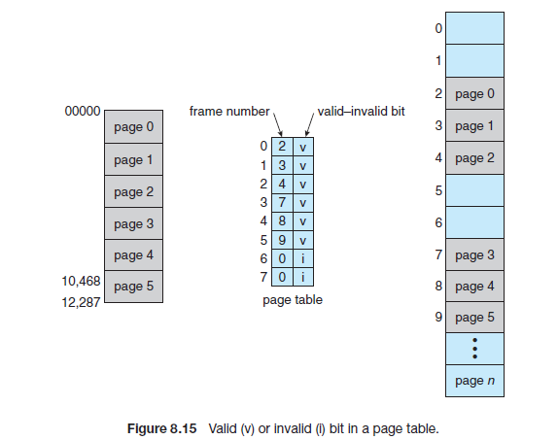

8.5.4 Shared Pages
One major advantage of paging is the ability to share common code among multiple processes. If a program contains reentrant (pure) code, only one copy of that code needs to be stored in physical memory, while multiple processes can execute it simultaneously. Reentrant code is non-self-modifying code, meaning it does not change during execution and is therefore safe to share.
As shown in Figure 8.16, multiple processes can share the same code pages (editor pages), while each process maintains its own separate data pages. The page tables of different processes map to the same physical code frames but to different data frames.

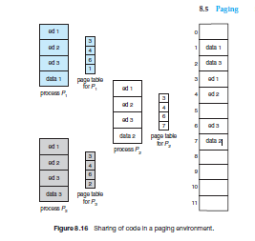
Without Shared Pages | With Shared Pages
40 users × (150 KB code + 50 KB data) = 8000 KB | 1 copy of 150 KB code + (40 × 50 KB data) = 2150 KB

This section discusses how operating systems manage large page tables efficiently in modern computer systems. As logical address spaces become very large (32-bit and 64-bit systems), storing a simple page table for every process requires a significant amount of memory. To overcome this problem, various page-table structures have been developed. Hierarchical Paging divides a large page table into multiple levels to reduce memory usage. Hashed Page Tables use hashing techniques to quickly locate page-table entries, making them suitable for large address spaces. Inverted Page Tables further reduce memory overhead by maintaining a single page-table entry for each physical frame rather than for each virtual page. Finally, the section examines Oracle SPARC Solaris, a real-world operating system that implements advanced page-table structures and TLB support for efficient memory management. Overall, this section focuses on optimizing page-table storage, reducing memory overhead, and improving address-translation efficiency in modern paging systems.

Section Number | Title | Main Topics Covered
8.6 | Structure of the Page Table | Different techniques for organizing large page tables efficiently
8.6.1 | Hierarchical Paging | Multi-level page tables, page table breakdown, reducing page-table memory usage
8.6.2 | Hashed Page Tables | Hash functions, hash table entries, virtual page number lookup, large address spaces
8.6.3 | Inverted Page Tables | Single global page table, frame-based entries, reduced memory overhead, process ID usage
8.6.4 | Oracle SPARC Solaris | Solaris memory management, hash-based page tables, TLB support, practical implementation of paging

8.6.1 Hierarchical Paging
Hierarchical paging is a technique used in modern operating systems to handle large virtual address spaces efficiently. Instead of using a single-level page table to map virtual addresses to physical addresses, hierarchical paging breaks the page table into multiple levels. This structure allows the operating system to use memory more efficiently, especially in systems with large address spaces.

Overview of Hierarchical Paging
In hierarchical paging, the virtual address is divided into several parts, each corresponding to a different level of page tables. These levels are typically organized as follows:
      - Page Directory: This is the first level of the page table, containing entries that point to second-level page tables.
      - Page Table: This is the second level of the page table, which contains entries pointing to the actual physical pages.
      - Page Frame: The final level contains the actual data, which resides in physical memory.

How Hierarchical Paging Works
To understand hierarchical paging, let’s consider an example using a two-level paging system. A virtual address in such a system is divided into three parts:
- Page Directory Index: The highest-order bits of the virtual address point to an entry in the page directory.
- Page Table Index: The next set of bits point to an entry in a page table.
- Page Offset: The remaining bits give the offset within the page.

Given these 32 bits, the system can address a 4 GB virtual memory space (2^32 bytes), with each page being 4 KB in size.
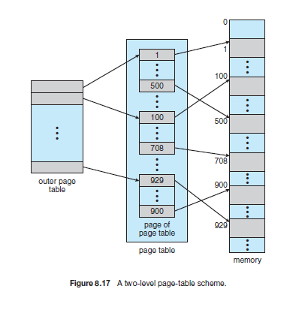

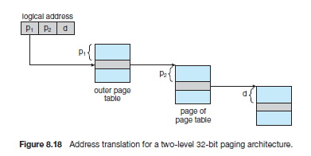
In a two-level paging scheme, the logical address is divided into:
- Outer Page Number (p₁) → indexes the outer page table
- Inner Page Number (p₂) → indexes the second-level page table
- Offset (d) → identifies the exact location within the page
Thus, the logical address format becomes:
<p₁, p₂, d>
The outer page table points to a second-level page table, and the second-level page table points to the actual frame in physical memory. This approach significantly reduces page-table memory requirements because only the necessary second-level page tables need to be created.

8.6.2 Hashed Page Tables
A common method for handling address spaces larger than 32 bits is the use of a hashed page table, where the virtual page number is hashed to determine its location in the table. Each entry in the hash table contains a linked list to manage collisions. The list's elements include three fields: (1) the virtual page number, (2) the mapped page frame, and (3) a pointer to the next element in the list.
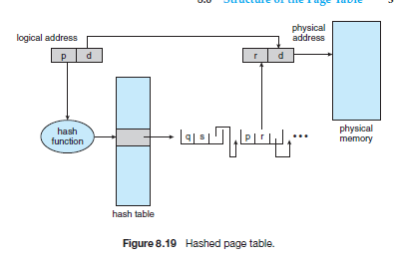

8.6.3 Inverted Page Tables

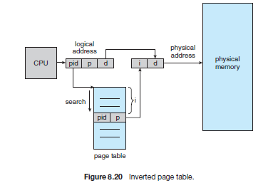
Inverted Page Tables reduce memory consumption by storing one entry per physical frame instead of one entry per virtual page, making them ideal for systems with very large address spaces.
In a traditional page table, every process has its own page table containing one entry for each virtual page. For systems with large address spaces, these page tables can contain millions of entries, consuming a significant amount of memory just to store page-mapping information.
To reduce this memory overhead, operating systems use an Inverted Page Table (IPT). Instead of having one page-table entry for every virtual page, an inverted page table contains one entry for each physical frame in memory. Therefore, the system maintains only one page table for the entire system, regardless of the number of processes.
Each entry in the inverted page table stores:
- Virtual Page Number (p)
- Process Identifier (PID / Address-Space Identifier)
- Information about the corresponding physical frame
When the CPU generates a logical address <PID, p, d>, the system searches the inverted page table to find the matching PID and virtual page number. Once found, the entry index provides the frame number, which is combined with the offset (d) to generate the final physical address.
Unlike a standard page table, where the page number directly indexes the table, an inverted page table requires a search operation. Therefore, systems often use hashing techniques to speed up the lookup process.
n a normal page table, every process maintains its own page table, and each entry stores the mapping from a virtual page number to a physical frame number (Page → Frame). If there are many processes and each process has thousands of pages, the total number of page-table entries becomes very large. In an Inverted Page Table, this arrangement is reversed (inverted). Instead of storing information page-wise, the system stores information frame-wise. There is only one global page table for the entire system, and each entry corresponds to a physical frame in RAM. Therefore, if RAM contains 100 frames, the inverted page table contains exactly 100 entries, regardless of how many processes or virtual pages exist.
When a page fault occurs, the operating system finds a free frame (or obtains one through page replacement), loads the required page from disk into that frame, and updates the inverted page table. For example, if Page 50 of Process P1 is loaded into Frame 3, the table stores the entry (Frame 3 → P1, Page 50). Later, when the CPU requests (P1, Page 50), the system searches the inverted page table to find which frame contains that page. Since searching the entire table can be slow, modern systems use hashing and TLBs to speed up the lookup process. Thus, the main advantage of an inverted page table is reduced memory overhead, while its main challenge is efficient searching.

